DAA Practical 7 – Coin Exchange Problem
Design and Analysis of Algorithms

Aim
To find the minimum number of coins required to make a given amount using Dynamic Programming.

Coin Exchange

1. Algorithm
Algorithm: Coin Exchange / Coin Change (Dynamic Programming)

Aim:
To find the minimum number of coins needed to make a given amount
using the available coin denominations.

Input:
- Number of coin types n
- Coin values
- Target amount A

Output:
- Minimum number of coins (or message if impossible)
- Execution time and complexity

Steps:
1. Start
2. Read coin values and amount A
3. Create array dp[0..A]
4. Set dp[0] = 0
5. Set dp[1], dp[2], ..., dp[A] = infinity
6. For i = 1 to A, repeat steps 7 to 9
7. For each coin in coins[], repeat steps 8 to 9
8. If coin <= i and dp[i - coin] is not infinity then
9. dp[i] = minimum of (dp[i], dp[i - coin] + 1)
10. If dp[A] is still infinity then
Print "amount cannot be formed"
Else
Print dp[A] as minimum coins
11. Stop

Idea:
dp[i] = minimum coins needed to make amount i.
Build answer for small amounts first, then use them for larger amounts.

Example:
Coins = [1, 2, 5, 10]
Amount = 18
Minimum coins = 4
(One possible way: 10 + 5 + 2 + 1)

Time Complexity: O(n * A)
Space Complexity: O(A)

2. Program Code (C Language)
File: Code/coin_exchange.c
#include <stdio.h>

#define BIG 99999 // means "not possible yet"

/*
Coin Exchange (Dynamic Programming)
Find minimum coins needed to make the given money
*/
int minCoins(int coin[], int types, int money)
{
int table[money + 1];

// pay = Represents the current amount we are trying to make.
// c = Represents the current coin we are testing.
int pay, c;
int using_this_coin;

// at start, mark all amounts as not possible
for (pay = 0; pay <= money; pay++)
table[pay] = BIG;

// 0 money needs 0 coins
table[0] = 0;

// make every amount from 1 to money
for (pay = 1; pay <= money; pay++)
{
// try each coin
for (c = 0; c < types; c++)
{
// coin can be used only if it is <= current amount
if (coin[c] <= pay && table[pay - coin[c]] != BIG)
{
// 1 current coin + best for remaining money
using_this_coin = table[pay - coin[c]] + 1;

// keep smaller count
if (using_this_coin < table[pay])
table[pay] = using_this_coin;
}
}
}

// still BIG means cannot make this money
if (table[money] == BIG)
return -1;

return table[money];
}

int main()
{
int types, money, i;
int answer;

printf("Enter number of coin types: ");
scanf("%d", &types);

int coin[types];

printf("Enter %d coin values:\n", types);
for (i = 0; i < types; i++)
scanf("%d", &coin[i]);

printf("Enter the amount: ");
scanf("%d", &money);

answer = minCoins(coin, types, money);

printf("\nCoins: ");
for (i = 0; i < types; i++)
printf("%d ", coin[i]);

printf("\nAmount: %d\n", money);

if (answer == -1)
printf("The amount cannot be formed using the given coins.\n");
else
printf("Minimum number of coins required: %d\n", answer);

printf("Time Complexity: O(n * A)\n");
printf("Space Complexity: O(A)\n");

return 0;
}

3. Output
Sample program output:
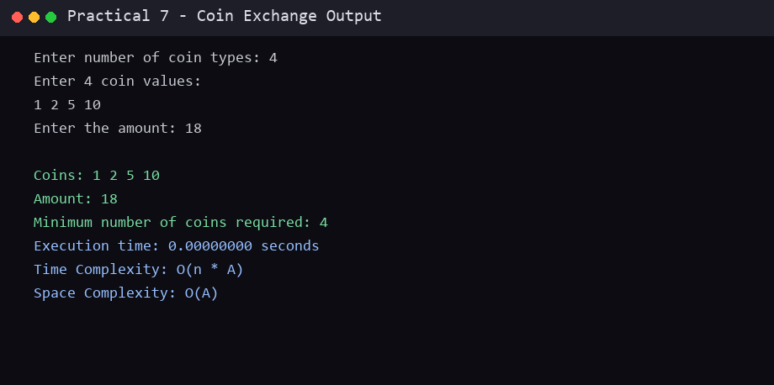

Conclusion
In this practical, the required algorithm(s) were studied and implemented successfully in C. The algorithm, program code and sample output are recorded above. This practical helped in understanding the working, advantages and complexity of the technique(s) used.
End of Practical 7

